# Lab 4: Create an Azure Stream Analytics instance

In this lab you will provision an Azure Stream Analytics instance.

In this lab the following actions will be performed:

* Define the Input Data Stream
* Define the Output Data Stream
* Write the Query

## What you will need

* Microsoft Azure Account
* Azure Resource Group
* Stream Analytics instance
* Organizational Account with PowerBI.

## Define the Input Data Stream

In this step we will define an Input stream for the stream analytics job.

1. Open the Azure Portal (<https://portal.azure.com>)
2. Click on: Resource groups > Your Resource group.
3. Click on: Your stream analytics job.
4. In the blade of the stream analytics job click on “Inputs”.

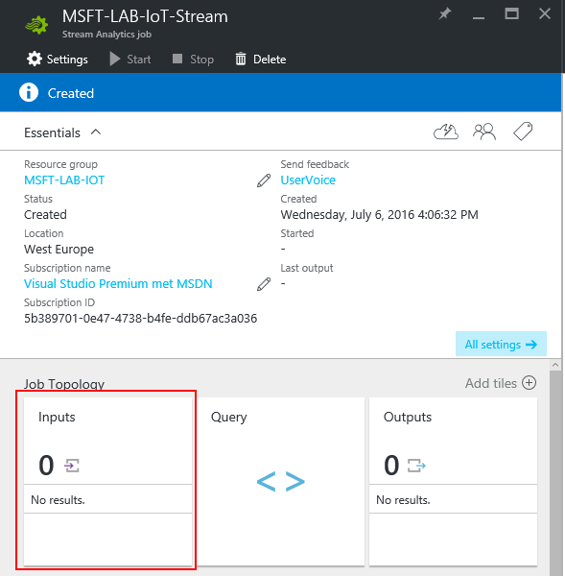

1. In the blade that appears click “Add”
2. In the New Input blade fill in the correct parameters.

|  |  |  |
| --- | --- | --- |
| Property | Description | Information |
| Input Alias | An alias that refers to your input. | Fill in a name for your input. |
| Subscription | The Azure subscription where in the IoT hub needs to be created | By default, you only have one subscription. If you have multiple subscriptions, select the correct one. |
| Source type | A stream analytics job needs at least one data stream input. There are two types of data: Data stream or Reference data. A data stream is a continuous sequence of data or events to be consumed and transformed by a Stream Analytics job. Reference data is auxiliary data used for correlation and lookups. Reference data is static or slow changing. | Select the option “Data Stream” because we will supply a stream of events. |
| Source | The source of the Data Stream | The source of our Data Stream will be a IoT Hub so select this option. |
| Subscription | The subscription the IoT Hub exists in. | Select the option: “Use IoT hub from current subscription”. |
| IoT Hub | The IoT hubs that are available within the current subscription. | Select the IoT hub you created. |
| Endpoint | The endpoint of the IoT hub you can choose between: Messaging and operations monitoring. | Select “Messaging” because we will work with the messages send to the IoT Hub. |
| Shared access policy name | The access policy the stream analytics job will use. | Select the policy you would like. For this lab we will use the iothubowner. |
| Consumer group | The consumer group of the IoT Hub | Use the default group. |
| Event serialization format | The type in which the events are serialized. | Select JSON. |
| Encoding | The encoding | Use UTF-8 this is the only type of encoding supported at this moment. |

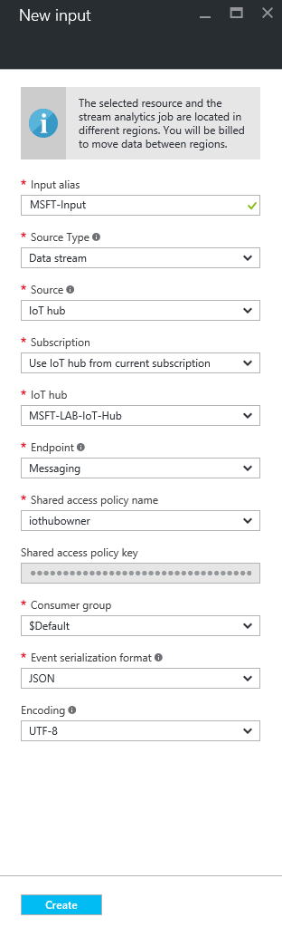

1. Click on “Create” to create the input.

## Output Stream

In the next section an output stream for stream analytics will be defined. If you want to output to PowerBI for realtime dash boarding continue to part 1. If you want to use a SQL database move to part 2.

You can also configure both output streams.

## Part 1 - Define the Output Data Stream – PowerBI

In this step we will define an output stream for the stream analytics job, best to create this after the PowerBI session.

1. On the Stream Analytics blade click on “Outputs”.

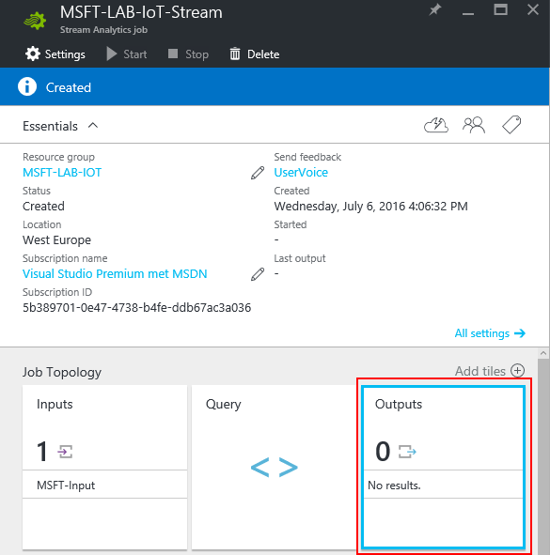

1. In the blade that appears click “Add”
2. In the New Output blade fill in the correct parameters.

|  |  |  |
| --- | --- | --- |
| Property | Description | Information |
| Output Alias | An alias that refers to your output. | Fill in a name for your output. |
| Sink | The output | Select PowerBI and authorize this with an organizational account by clicking on the Authorize button. |
| Group Workspace | The workspace to send the data to | Select the My Workspace |
| Dataset Name | The name of the Dataset | Supply a name you want. |
| Table Name | The name of the table | Supply a name you want. |

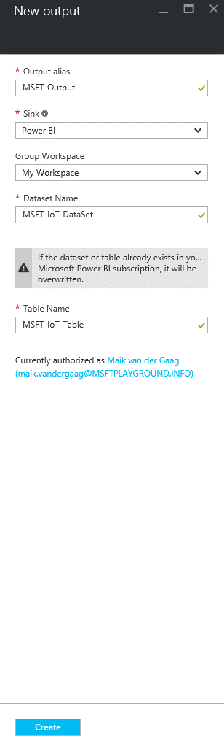

1. Click on “Create” to create the output.

## Part 2 - Define the Output Data Stream – SQL

In this part you will configure Stream Analytics to output information to SQL server.

1. Click on: Resource groups > Your Resource group.
2. In the blade of your resource group click on “Add”

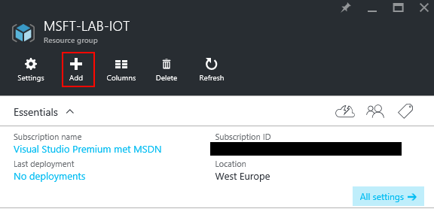

1. In the blade that appears search for “SQL Database” and click on the first result, in the new blade that appears click on “Create”.

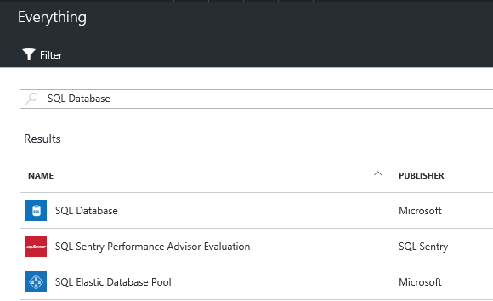

1. Again a new blade will appear. In this blade you have to enter the properties of the SQL Database.

|  |  |  |
| --- | --- | --- |
| Property | Description | Information |
| Database Name | The name of the database | You can pick any name you want. It will be validated when entering the text. |
| Subscription | The Azure subscription where in the IoT hub needs to be created | By default, you only have one subscription. If you have multiple subscriptions select the correct one. |
| Resource group | The container where in you want to create the IoT hub | Use “Use existing” to create it in the resource group created in the previous step. |
| Select Source | The source for the database. This could be a backup. | By default it is set to “blank”, use this option. |
| Server | The SQL server that hosts the database. | You can use an existing or create a new one. Click on “Configure required settings” to configure the database server and fill in the correct properties and then click select. |
| Pricing Tier | The pricing tier for your service. | Select the pricing tier and choose the option B Basic. |
| Collation | The collation of the SQL database | Keep it to the default. |

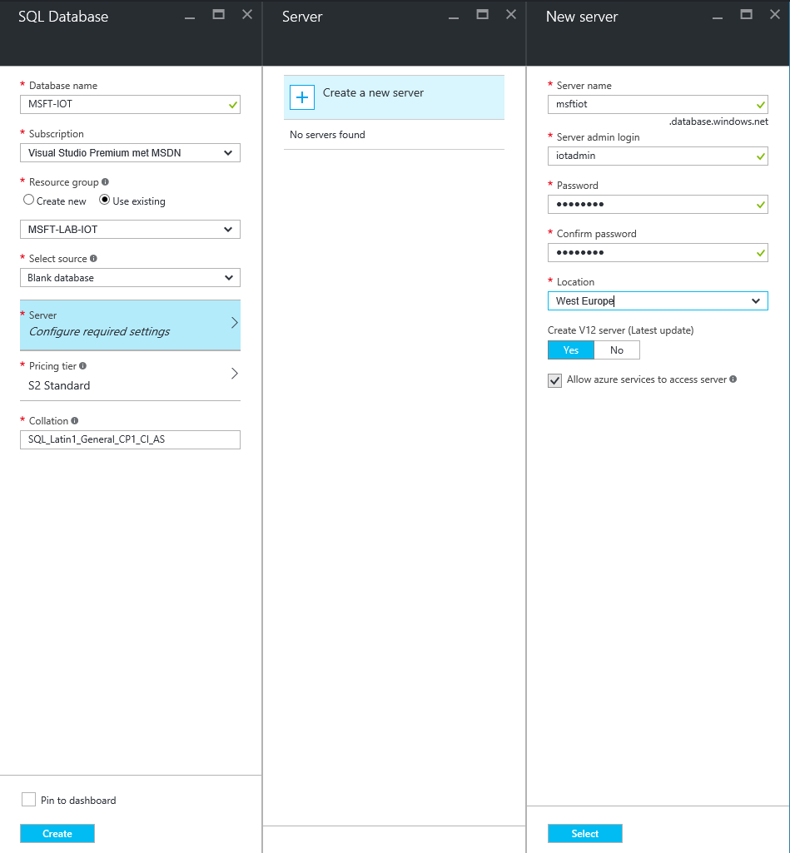

1. After you have selected the SQL server click create to create the database.
2. After the Database and Database server is created, open the resource group and click on your created SQL server.
3. In the blade that is opened click on “Show Firewall settings”.
4. In the firewall settings blade add a firewall rule to include all IP Addresses.

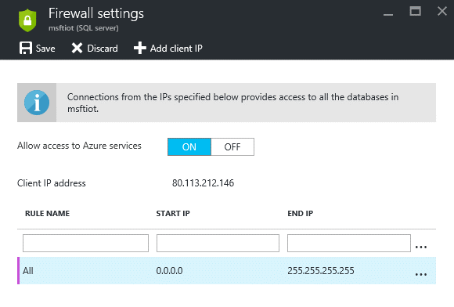

1. Click save.
2. After the settings are saved is created open de SQL management studio or any other SQL tool and perform the following SQL script to create a table.

|  |
| --- |
| USE [SensorDataDB]  GO  /****** Object:  Table [dbo].[DeviceMessages]    Script Date: 05-Aug-16 13:22:25 ******/  SET ANSI_NULLS ON  GO  SET QUOTED_IDENTIFIER ON  GO  CREATE TABLE [dbo].[DeviceMessages](         [Id] [int] IDENTITY(1,1) NOT NULL,         [DeviceID] [varchar](12) NOT NULL,         [DeviceType] [varchar](50) NOT NULL,         [mV] [int] NOT NULL,         [Temp] [float] NOT NULL,         [PartitionId] [int] NOT NULL,         [EventEnqueuedUtcTime] [datetime2](7) NOT NULL,         [EventProcessedUtcTime] [datetime2](7) NOT NULL,         [WindowTime] [datetime2](7) NOT NULL,  CONSTRAINT [PK_Id] PRIMARY KEY CLUSTERED  (         [Id] ASC  )WITH (PAD_INDEX = OFF, STATISTICS_NORECOMPUTE = OFF, IGNORE_DUP_KEY = OFF, ALLOW_ROW_LOCKS = ON, ALLOW_PAGE_LOCKS = ON)  )  GO |

1. On the Stream Analytics blade click on “Outputs”.



1. In the blade that appears click “Add”
2. In the New Output blade fill in the correct parameters.

|  |  |  |
| --- | --- | --- |
| Property | Description | Information |
| Output Alias | An alias that refers to your output. | Fill in a name for your output. |
| Sink | The output | Select SQL Database |
| Subscription | The Azure subscription where in the IoT hub needs to be created | By default you only have one subscription. If you have multiple subscriptions select the correct one. |
| Database | The name of the database | Select the database it needs to use |
| Username | The username to connect to the database | Supply the correct username |
| Password | The password of the user that needs to connect to the database | Supply the correct password |
| Table | The table name to save the information in. | Supply the table name in your database if you used the script fill in: “DeviceMessages”. |

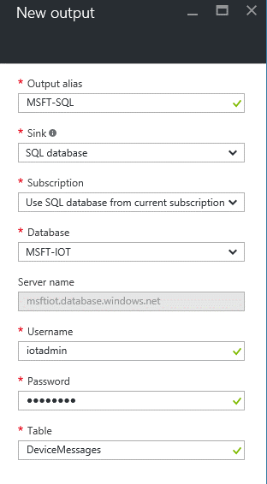

1. Select “Create” to create the output.

## Write the Query

In this step we will write a query to select the correct data.

1. On the Stream Analytics blade click on “Query”.

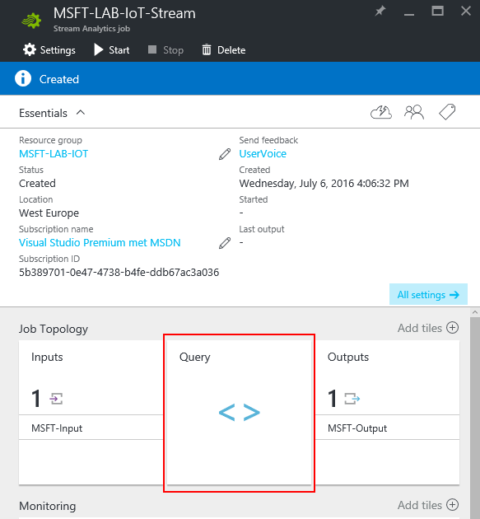

1. Enter the query you would like to do on the data you supply to the IoT hub. You could add a TimeStamp by using: “System.Timestamp AS Timestamp” in the Select Query.

A good example for the query is the following:

**SQL Database output**

The FROM should represent the Input and the output name should be represented in the INTO statement.

|  |
| --- |
| SELECT  DeviceID,  DeviceType,  CAST(MIN(mV) as bigint) as mV,  AVG(Temp) as Temp,  PartitionId,  MAX(CAST(EventEnqueuedUtcTime as datetime)) as EventEnqueuedUtcTime,  MAX(CAST(EventProcessedUtcTime as datetime)) as EventProcessedUtcTime,  System.Timestamp as WindowTime  INTO  [SensorDataDB]  FROM  [DeviceMessages]  GROUP BY DeviceID, DeviceType, PartitionId, TumblingWindow(mi,5) |

**PowerBI output**

The FROM should represent the Input and the output name should be represented in the INTO statement.

|  |
| --- |
| SELECT  DeviceID,  CAST(MIN(mV) as bigint) as mV,  AVG(Temp) as Temp,  System.Timestamp as Time  INTO  [PowerBi]  FROM  [DeviceMessages]  GROUP BY DeviceID, TumblingWindow(mi,5) |

## Cleanup.

The following actions will delete all resources created within this Lab, if you want to keep the resources you can skip this step.

1. Navigate to the Azure Portal (<https://portal.azure.com>).
2. Click on: Resource group > Your Resource Group you created for this Lab
3. In the top bar click on: “Delete”.